SESSION 15
ANOVA (Analysis of Variance)
Assignment Notes with Worked Demo
Topics covered: One-way ANOVA | Between-group vs Within-group Variance | Use-case: Comparing Means of 3 Customer Groups | Demo: Average Purchase Values Across Age Groups

1. Why ANOVA?
A t-test compares the means of two groups. When we need to compare three or more groups (for example, three customer segments), we use Analysis of Variance (ANOVA). It tests all the group means at once to find out whether at least one of them differs from the others.

1.1 Why not run several t-tests?
Comparing three groups with separate t-tests needs 3 tests (A vs B, A vs C, B vs C). Each test at α = 0.05 carries a 5% risk of a false positive, so the overall chance of at least one false positive rises to:
1 − (0.95)³ = 0.143 (about 14.3%)
With more groups the problem gets worse. ANOVA performs a single overall test that keeps the Type I error at α.

2. One-way ANOVA
One-way ANOVA tests whether the means of k independent groups are equal, using one categorical factor (for example, age group) and one numerical outcome (for example, purchase value).

2.1 Hypotheses
- H₀: μ₁ = μ₂ = … = μₖ (all group means are equal).
- H₁: at least one group mean is different.
Note that H₁ does not say which group differs or how many differ. That needs a follow-up (post-hoc) test.

2.2 Assumptions
- Independence: observations are independent, and each belongs to only one group.
- Normality: the outcome is approximately normal within each group (less important with equal and reasonably large group sizes).
- Equal variances (homogeneity): the groups have similar spread. This can be checked with Levene’s test.

2.3 Notation and formulas
Let k be the number of groups, nᵢ the size of group i, N the total number of observations, X̅ᵢ the mean of group i and X̅ the grand mean.
Quantity | Formula
Between-group sum of squares | SSB = Σ nᵢ (X̅ᵢ − X̅)²
Within-group sum of squares | SSW = Σ Σ (Xᵢⱼ − X̅ᵢ)²
Total sum of squares | SST = SSB + SSW
Degrees of freedom | df between = k − 1, df within = N − k
Mean squares | MSB = SSB / (k − 1), MSW = SSW / (N − k)
F statistic | F = MSB / MSW

2.4 ANOVA table layout
Source | Sum of squares | df | Mean square | F | p
Between groups | SSB | k − 1 | MSB | MSB / MSW | p-value
Within groups | SSW | N − k | MSW
Total | SST | N − 1

Decision rule: Reject H₀ if F is larger than the critical value F(α; k − 1, N − k), or equivalently if the p-value is at most α. ANOVA F-tests are always right-tailed.

3. Between-group vs Within-group Variance
ANOVA gets its name because it decides whether means differ by comparing two kinds of variance.
- Between-group variance (MSB): how far the group means are from the grand mean. It reflects real differences between groups plus random noise.
- Within-group variance (MSW): how much individual values vary around their own group mean. It reflects random noise only.
F = Between-group variance / Within-group variance = MSB / MSW
- If H₀ is true, both estimate the same random noise, so F is close to 1.
- If the group means really differ, MSB becomes much larger than MSW, so F is large and H₀ is rejected.

3.1 Small worked example
Three groups of four observations each: A = 10, 12, 11, 13 (mean 11.5); B = 14, 15, 13, 16 (mean 14.5); C = 18, 17, 19, 20 (mean 18.5). The grand mean is 14.83.
SSB = 4[(11.5 − 14.83)² + (14.5 − 14.83)² + (18.5 − 14.83)²] = 98.67
SSW = 5 + 5 + 5 = 15
MSB = 98.67 / 2 = 49.33, MSW = 15 / 9 = 1.667, F = 49.33 / 1.667 = 29.6
With df = (2, 9) the p-value is 0.0001, so H₀ is rejected: the group means are not all equal. The groups are well separated compared with the spread inside each group, which gives the large F.

4. Use-case: Comparing the Means of 3 Customer Groups
Businesses often split customers into groups and want to know whether the groups behave differently. ANOVA answers this for a numerical measure such as spend, visits or satisfaction score.
Customer groups | Outcome measured | Business decision
Loyalty tiers (Silver, Gold, Platinum) | Average annual spend | Is the loyalty programme linked to higher spend?
Age groups (young, middle, senior) | Average purchase value | Which group should a campaign target?
Acquisition channels (web, app, store) | Average order value | Where should the marketing budget go?

4.1 Typical workflow
- State H₀ (all group means equal) and H₁ (at least one differs); choose α = 0.05.
- Check the assumptions (Levene’s test for equal variances; normality of each group).
- Run one-way ANOVA and read the F statistic and p-value.
- If H₀ is rejected, run a post-hoc test such as Tukey’s HSD to find which pairs of groups differ.
- Report the effect size (eta-squared, η² = SSB / SST) and interpret the result for the business.

5. Demo: Average Purchase Values Across Age Groups

5.1 Problem statement
A retailer recorded the purchase value (Rs.) of 10 randomly chosen customers in each of three age groups: 18–25, 26–40 and 41 and above. Test whether the average purchase value differs across the age groups. The data are illustrative for this demo.

5.2 Hypotheses
- H₀: μ₁ = μ₂ = μ₃ (average purchase value is the same in all age groups).
- H₁: at least one age group has a different average purchase value.
Significance level: α = 0.05.

5.3 Data
Customer | 18–25 | 26–40 | 41+
1 | 420 | 510 | 455
2 | 380 | 470 | 430
3 | 450 | 560 | 480
4 | 400 | 495 | 445
5 | 430 | 535 | 470
6 | 390 | 480 | 420
7 | 410 | 525 | 465
8 | 440 | 545 | 440
9 | 370 | 465 | 415
10 | 460 | 555 | 485
Mean | 415.00 | 514.00 | 450.50
Std. deviation | 30.28 | 35.26 | 24.55

Grand mean = 459.83. The group means are clearly different, and the group with ages 26–40 spends the most.

5.4 Python code
import numpy as np
from scipy import stats

g1 = [420,380,450,400,430,390,410,440,370,460] # 18-25
g2 = [510,470,560,495,535,480,525,545,465,555] # 26-40
g3 = [455,430,480,445,470,420,465,440,415,485] # 41+

# One-way ANOVA
F, p = stats.f_oneway(g1, g2, g3)
print('F =', F, ' p =', p)

# Assumption checks
print('Levene p =', stats.levene(g1, g2, g3).pvalue)
print([stats.shapiro(g).pvalue for g in (g1, g2, g3)])

# Post-hoc: Tukey HSD
print(stats.tukey_hsd(g1, g2, g3))

5.5 ANOVA table
Source | Sum of squares | df | Mean square | F | p
Between groups | 50,311.67 | 2 | 25,155.83 | 27.32 | < 0.001
Within groups | 24,862.50 | 27 | 920.83
Total | 75,174.17 | 29

F = MSB / MSW = 25,155.83 / 920.83 = 27.32
The critical value is F(0.05; 2, 27) = 3.354 and the exact p-value is about 0.0000003.
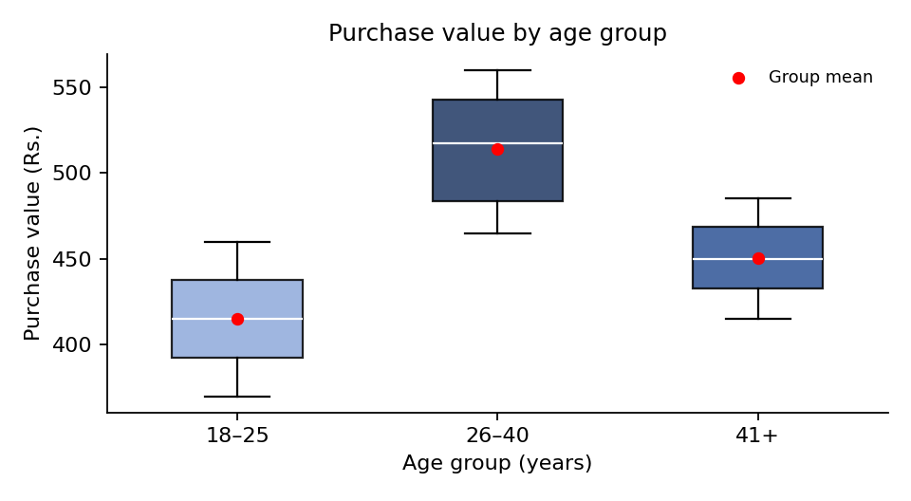
Figure 1: Purchase value by age group (red dots show group means)

5.6 Assumption checks
- Equal variances: Levene’s test gives p = 0.347, so equal variances are reasonable.
- Normality: Shapiro–Wilk p-values are 0.89, 0.43 and 0.72 for the three groups, so there is no sign of non-normality.
- Independence and balance: customers were sampled at random and each group has 10 customers.

5.7 Decision
Since F = 27.32 is greater than the critical value 3.354 (p < 0.001), we reject H₀. There is strong evidence that average purchase value is not the same in all three age groups.

5.8 Post-hoc comparison (Tukey’s HSD)
ANOVA shows that some difference exists, but not where. Tukey’s test compares every pair of groups while controlling the overall error rate.
Comparison | Mean difference | p-value | 95% CI for the difference
26–40 vs 18–25 | +99.0 | < 0.001 | (65.35, 132.65)
41+ vs 18–25 | +35.5 | 0.037 | (1.85, 69.15)
26–40 vs 41+ | +63.5 | < 0.001 | (29.85, 97.15)

All three pairs differ significantly at the 5% level. The 26–40 group spends the most, the 41+ group is in the middle and the 18–25 group spends the least.

5.9 Effect size
η² = SSB / SST = 50,311.67 / 75,174.17 = 0.669
About 67% of the variation in purchase value is explained by age group, which is a large effect.

5.10 Conclusion
The average purchase value differs significantly across age groups (F(2, 27) = 27.32, p < 0.001, η² = 0.67). Customers aged 26–40 spend about Rs. 514 on average, compared with Rs. 450 for those aged 41 and above and Rs. 415 for those aged 18–25. The retailer could focus premium offers on the 26–40 group and use targeted promotions to raise the spend of the youngest group.
Note: ANOVA shows that the means differ, not why. Other factors such as income or product category may also influence purchase value.

6. Formula Cheat Sheet
Concept | Formula
Between-group SS | SSB = Σ nᵢ (X̅ᵢ − X̅)²
Within-group SS | SSW = Σ Σ (Xᵢⱼ − X̅ᵢ)²
Total SS | SST = SSB + SSW
Degrees of freedom | k − 1 (between), N − k (within), N − 1 (total)
Mean squares | MSB = SSB / (k − 1), MSW = SSW / (N − k)
F statistic | F = MSB / MSW
Effect size | η² = SSB / SST
Decision rule | Reject H₀ if F > critical value (or p ≤ α)

